

**Figure 1: Logical diagram of the network to be configured**

Use Figure 1 and Table 1 to configure a four-router network. All router configurations must be done using a PC connected to the router’s console port through its RS232 serial port. Attempt to use the graphical user interface for router configuration will result in failing the test. Choose the following types of devices:

**Routers**: 2621XM, **Switches**: 2950T-24, **End Devices**: PC-PT

|  |  |  |  |  |  |
| --- | --- | --- | --- | --- | --- |
| **Network/SubNet** | **Address** | **Mask** | **First Host Address** | **Last Host Address** | **Broadcast Address** |
| Subnet A | 160.1.0.0 | 255.255.254.0 | 160.1.0.1 | 160.1.1.254 | 160.1.1.255 |
| Subnet B | 160.1.2.0 | 255.255.254.0 | 160.1.2.1 | 160.1.3.254 | 160.1.3.255 |
| Subnet C | 160.1.4.0 | 255.255.254.0 | 160.1.4.1 | 160.1.5.254 | 160.1.5.255 |
| Subnet D | 160.1.6.0 | 255.255.254.0 | 160.1.6.1 | 160.1.7.254 | 160.1.7.255 |
| Network 1 | 198.1.0.0 | 255.255.255.0 | 198.1.0.1 | 198.1.0.254 | 198.1.0.255 |
| Network 2 | 198.1.1.0 | 255.255.255.0 | 198.1.1.1 | 198.1.1.254 | 198.1.1.255 |
| Network 3 | 198.1.2.0 | 255.255.255.0 | 198.1.2.1 | 198.1.2.254 | 198.1.2.255 |
| Subnet E | 198.1.3.64 | 255.255.255.192 | 198.1.3.65 | 198.1.3.126 | 198.1.3.127 |
| Subnet F | 198.1.3.128 | 255.255.255.192 | 198.1.3.129 | 198.1.3.190 | 198.1.3.191 |
| Serial 1 | 198.1.3.0 | 255.255.255.252 | 198.1.3.1 | 198.1.3.2 | No need |
| Serial 2 | 198.1.3.4 | 255.255.255.252 | 198.1.3.5 | 198.1.3.6 | No need |
| Serial 3 | 198.1.3.8 | 255.255.255.252 | 198.1.3.9 | 198.1.3.10 | No need |

**Table 1: IP addressing for the network given**

First fill in the table. [33 Marks]

Then, configure the following as stated:

1. Hostname for ALL routers [2 Marks]
2. Message of the day for Router A only [2 Marks]
3. Console password (use *cisco*) for Router A only [2 Marks]
4. Enable password (use *class*) Router A only [2 Marks]
5. Telnet access (password *cisco*) for Router A only [5 Marks]
6. All interface IP addresses so that interfaces become live [12 Marks]
7. An appropriate version of the routing protocol RIP for ALL routers [8 Marks]
8. All PCs [4 Marks]

**Testing:** Before this step the tutor would confirm that the configuration has been carried out from console.

**Tutor’s Signature**:

|  |  |  |
| --- | --- | --- |
| **Configuration/Test** | **Tutor’s comments** | **Tutor’s signature** |
| *Hostname* | All the 4 routers are assigned with a host name A,B,C,D respectively | **Bakary Badjie** |
| *Message of the day* | Welcome Authorized access Unauthorized access Prohibited | **Bakary Badjie** |
| *Console password* | cisco | **Bakary Badjie** |
| *Enable password* | Successful | **Bakary Badjie** |
| *Telnet from PC0 to Router A* | Successful | **Bakary Badjie** |
| *Telnet from PC1 to Router A* | Successful | **Bakary Badjie** |
| *All fifteen interfaces* | Successful | **Bakary Badjie** |
| *Routing protocol (RIP)* | Successful | **Bakary Badjie** |
| *Routing table* | Successful | **Bakary Badjie** |
| *Ping from PC0 to PC 1* | successful | **Bakary Badjie** |

[30 Marks]

**Introduction**

The primary objective of this project is to implement and demonstrate a network design that can satisfy data communication requirements between individual PCs using routers and switches while minimizing the expenses in order to satisfy this requirements. However, this network requirements can widely be different from one network to another depending on the geographical particularities as well as the nature of the data that need to be transport from one end to another. In this way, resources can be effectively shared between different users i.e. to make available all program, dates, hardware etc. to every networks regardless of the physical location of the resources and the users which can produce an effective data communication between different users.

**User Requirements**

**Interactivity**

This network framework is designed to concentrate on the respond time of the system and the capacity of a PC to reply to the user input. Interactivity is probably going to be related to wireless device access, for example, the internet, mouse, reaction Keyboard, and so forth. In this designed network, organizations such as universities can collaborate with the system and receive a quick response when conducting activities such as online enrollment, distance learning, etc.

**Reliability**

In this framework, Reliability is in coordination with accessibility from the user's perspective. The system always available promptly and accessible for all the authorized users any time they might want to get access to the network system without any hindrance and furthermore the degree of service availability must be consistent to all the authorized users.

**Versatility**

This might be identified with a process where an intuitive framework (versatile framework) adopts its conduct or behaviors to individual users depending on the data needed by the user. In this network, as the users continue to utilize the network, they depend on it to an ever increasing extent, which means the users do not need to stress over themselves about where the servers are situated as long as they can get their required services. For instance, users will have the option to get and send data from various streams utilizing our network framework.

**Security**

Security of any network framework is very significant requirement as it lessens or terminates the risk of the data fall in hands of wrong or unauthorized persons. From the user's point of view, security is a necessity that should ensure the secrecy of the user's information.

**Application Requirements**

* The below mentioned applications can be associated with our this network framework
* University online activities such as;

1. Oibs
2. Distance learning platform.
3. student information system
4. Student discussion platforms.
5. Etc.

**Network Implementation**

The following tools are used for the successful implementation of this network.

* Cisco Package Tracer
* Four 2621XM routers
* Nine 2950T-24 Switches
* Four PC-PT PCs
* VLSM (Variable Length Sub-netting Mask)
* Copper straight through wire
* Console Cable
* Serial DTE

In this design, we used four routers, nine switches and four PCs for the network implementation. The idea of using different switches for a single router is because for instance if there is a problem in one of the switches within the network, the user can tap to the other switches to access the network without any from or conflict between the users.

**VLSM calculation:**

For subnet A, B, C, and D, there is no requirement to borrow any bit. Therefore we used all the bits available, and we used the formula 2n – 2 which is equal to 28- 2 = 254 but this not a stable address. Therefore, we minus 254 from 254 which is equal to 0 then our sub masks are equal to 255.255.255.0

For subnet E and F, we borrowed 2 bits from Class C network, then we are left with 6 bits. Then, we used the formula 2n – 2 which is also equal to 26- 2 = 62 but this also not a stable address. Therefore we minus 62 from 254 minus 62, then we acquired 192 and our subnet mask becomes 255.255.255.192

For serial 1, 2, and 3, we borrowed 6 bits and we are left with 2 bits, and by using the above formula, we get 4. Then we minus 2 from 254 and get 252 and subnet mask becomes 255.255.255.252

**Network Architecture**

Here we are showing our network structural design which demostrates how the individual PCs are connected to router as well as to different subnets and networks. This will give us the general understanding of how the network is been structured.

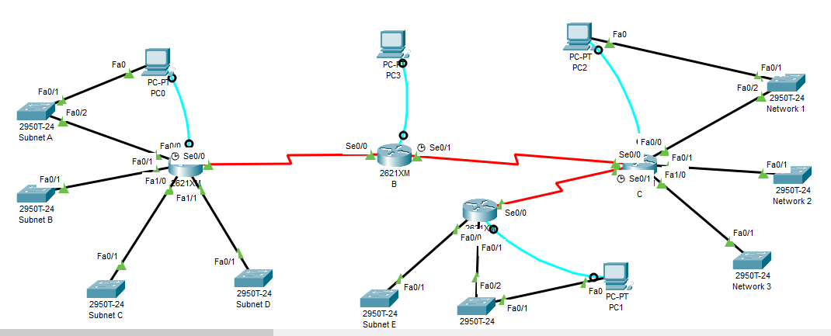

**Configuration for all the Routers through their connected**

|  |
| --- |
| **Router A**  Router>enable  Router#configure terminal  Router(config)#hostname A  A(config)#enable secret class  A(config)#line con 0  A(config)#line vty 0 4  A(config-line)#password cisco  A(config-line)#login  A(config-line)#password cisco  A(config-line)#login  A(config-line)#end  A(config-line)#banner motd # Welcome Authorized access Unauthorized access Prohibited#  A(config-line)#exit  A(config)#interface Fa0/0  A(config-if)#ip address 160.1.3.2 255.255.254.0  A(config-if)#description A Fa0/0  A(config-if)#no shutdown  A(config-if)#exit  A(config)#interface Fa0/1  A(config-if)#ip address 160.1.5.2 255.255.254.0  A(config-if)#description A Fa0/1  A(config-if)#no shutdown  A(config-if)#exit  A(config)#interface Fa1/0  A(config-if)#ip address 160.1.7.2 255.255.254.0  A(config-if)#description A Fa1/0  A(config-if)#no shutdown  A(config-if)#exit  A(config)#interface Fa1/1  A(config-if)#ip address 160.1.9.2 255.255.254.0  A(config-if)#description A Fa1/1  A(config-if)#no shutdown  A(config-if)#exit  A(config)#interface Se0/0  A(config-if)#ip address 198.1.3.1 255.255.255.252  A(config-if)#description A Se0/0  A(config-if)#no clock rate 56000  A(config-if)#no shutdown  A(config-if)#exit  A(config)#exit  A#copy running-config startup-config |
|  |
| **Router B**  Router>enable  Router#configure terminal  Router(config)#hostname B  B(config)#interface Se0/0  B(config-if)#ip address 198.1.3.2 255.255.255.252  B(config-if)#description B Se0/0  B(config-if)#no shutdown  B(config-if)#exit  B(config)#interface Se0/1  B(config-if)#ip address 198.1.3.5 255.255.255.252  B(config-if)#description B Se0/1  B(config-if)#no shutdown  B(config-if)#exit  B(config)#exit  B# copy running-config startup-config |

|  |
| --- |
| **Router C**  Router>enable  Router#configure terminal  Router(config)#hostname C  C(config)#interface Fa0/0  C(config-if)#ip address 160.3.112 255.255.254.0  C(config-if)#description C Fa0/0  C(config-if)#no shutdown  C(config-if)#exit  C(config-if)#interface Fa0/1  C(config-if)#ip address 160.1.3.115 255.255.254.0  C(config-if)#description C Fa0/1  C(config-if)#no shutdown  C(config-if)#exit  C(config)#interface Fa1/0  C(config-if)#ip address 160.1.3.123 255.255.254.0  C(config-if)#description C Fa1/0  C(config-if)#no shutdown  C(config-if)#exit  C(config)#interface Se0/0  C(config-if)#ip address 198.1.3.6 255.255.255.252  C(config-if)#description C Se0/0  C(config-if)#no shutdown  C(config-if)#exit  C(config)#interface Se0/1  C(config-if)#ip address 198.1.3.9 255.255.255.252  C(config-if)#description C Se0/1  C(config-if)#no clock rate 56000  C(config-if)#no shutdown  C(config-if)#exit  C(config)#exit  C# copy running-config startup-config |

|  |
| --- |
| **Router D**  Router>enable  Router#configure terminal  Router(config)#hostname D  D(config)#interface Fa0/0  D(config-if)#ip address 160.3.152 255.255.254.0  D(config-if)#description D Fa0/0  D(config-if)#no shutdown  D(config-if)#exit  D(config)#interface Fa0/1  D(config-if)#ip address 160.1.3.154 255.255.254.0  D(config-if)#description D Fa0/1  D(config-if)#no shutdown  D(config-if)#exit  D(config)#interface Se0/0  D(config-if)#ip address 198.1.3.10 255.255.255.252  D(config-if)#description C Se0/0  D(config-if)#no shutdown  D(config-if)#exit  D(config)#exit  D# copy running-config startup-config |

**Screenshot of all the PCs configuration**

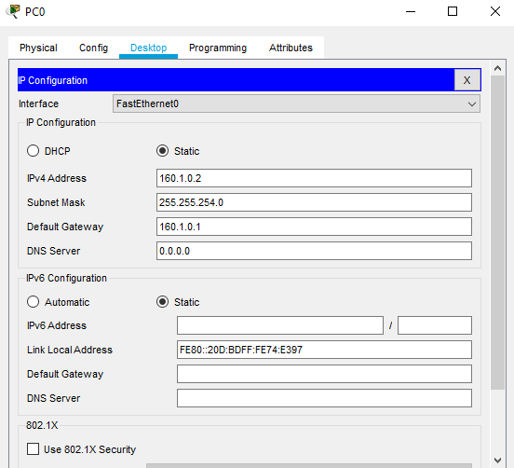 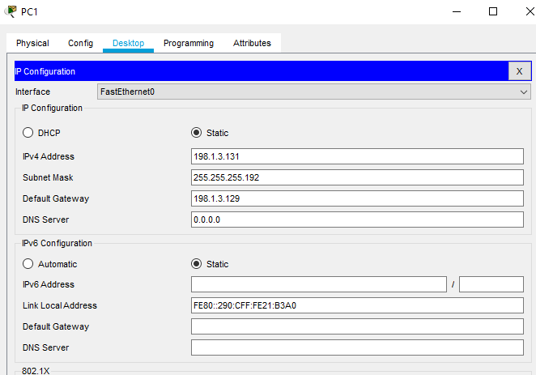 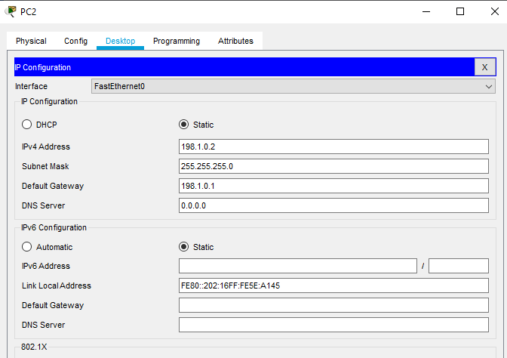 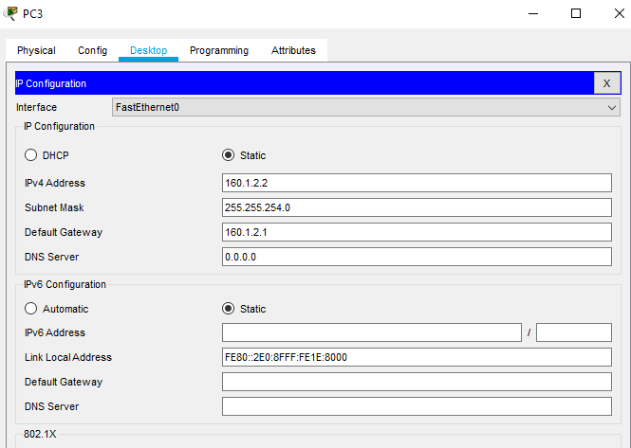

**Routing Table**

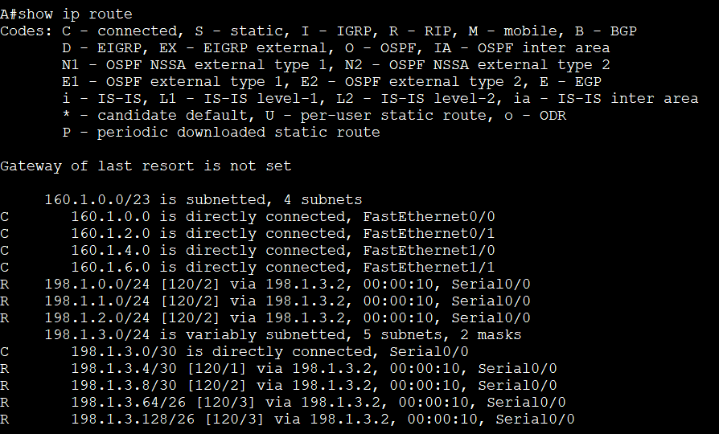

**Screenshot of RIP Configuration for all the Route**

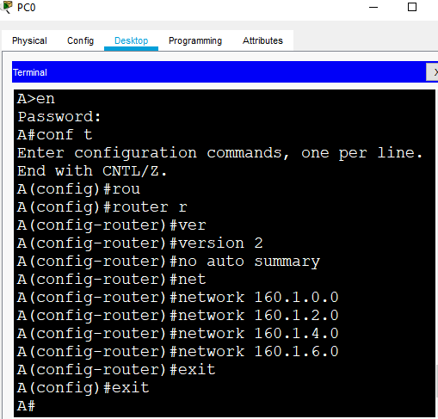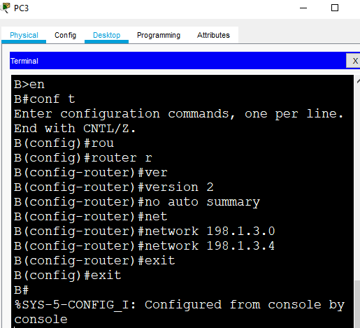

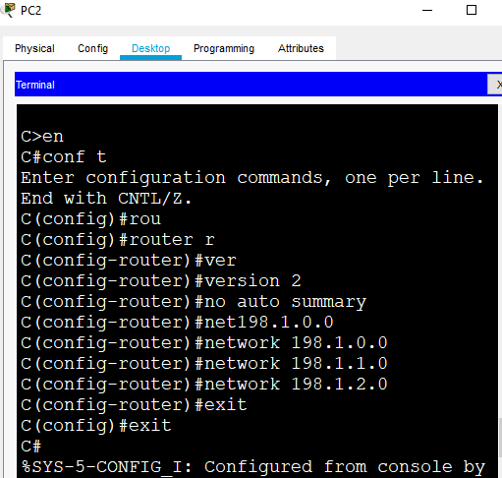 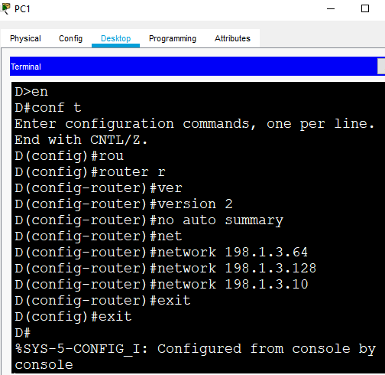

**Results and Discussions**

After the successful implimentation of this framework,we are required put our data into test to see if there is successfully transfer of data between users without errors. Attached below is the screenshots of our pinging from PC0 to PC1 and the routing table

**Ping PC0 to PC1**

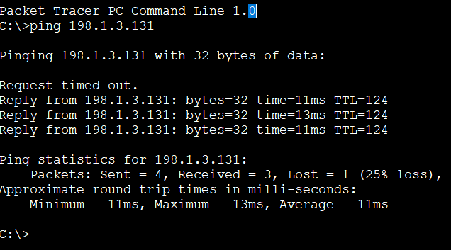

**Conclusion**

We have effectively architect and implemented our proposed network framework to facilitate or provide data communication for any installation also all essential testing were done. The system is fruitful and no blunders or errors were experienced.

Taking everything into account, the Network is significant in our regular daily existence, in a network at least two PCs are connected together to communicate with each other by exchanging data using the principles of data communication in accordance to various network protocols. We conclude that there is no organization, universities, homes, public installations, commercial installations, etc. would not have the option to convey and exchange information adequately. The network has a ton of preferred positions for the user. Regardless of whether it is wired or remote. Therefore, networking plays a vital role in today's world of technology.